**Informative Reports**





*Focus on Informative Reports*

Read the sample informative report on the next page and answer these questions:

1. What is its purpose? Does the writer ask the reader to do anything?
2. Can you determine the audience for whom this report was intended?
3. What would make this report more useful and easier to read?
4. In what fields might a report of this nature be needed?

**186 |** Chapter 8

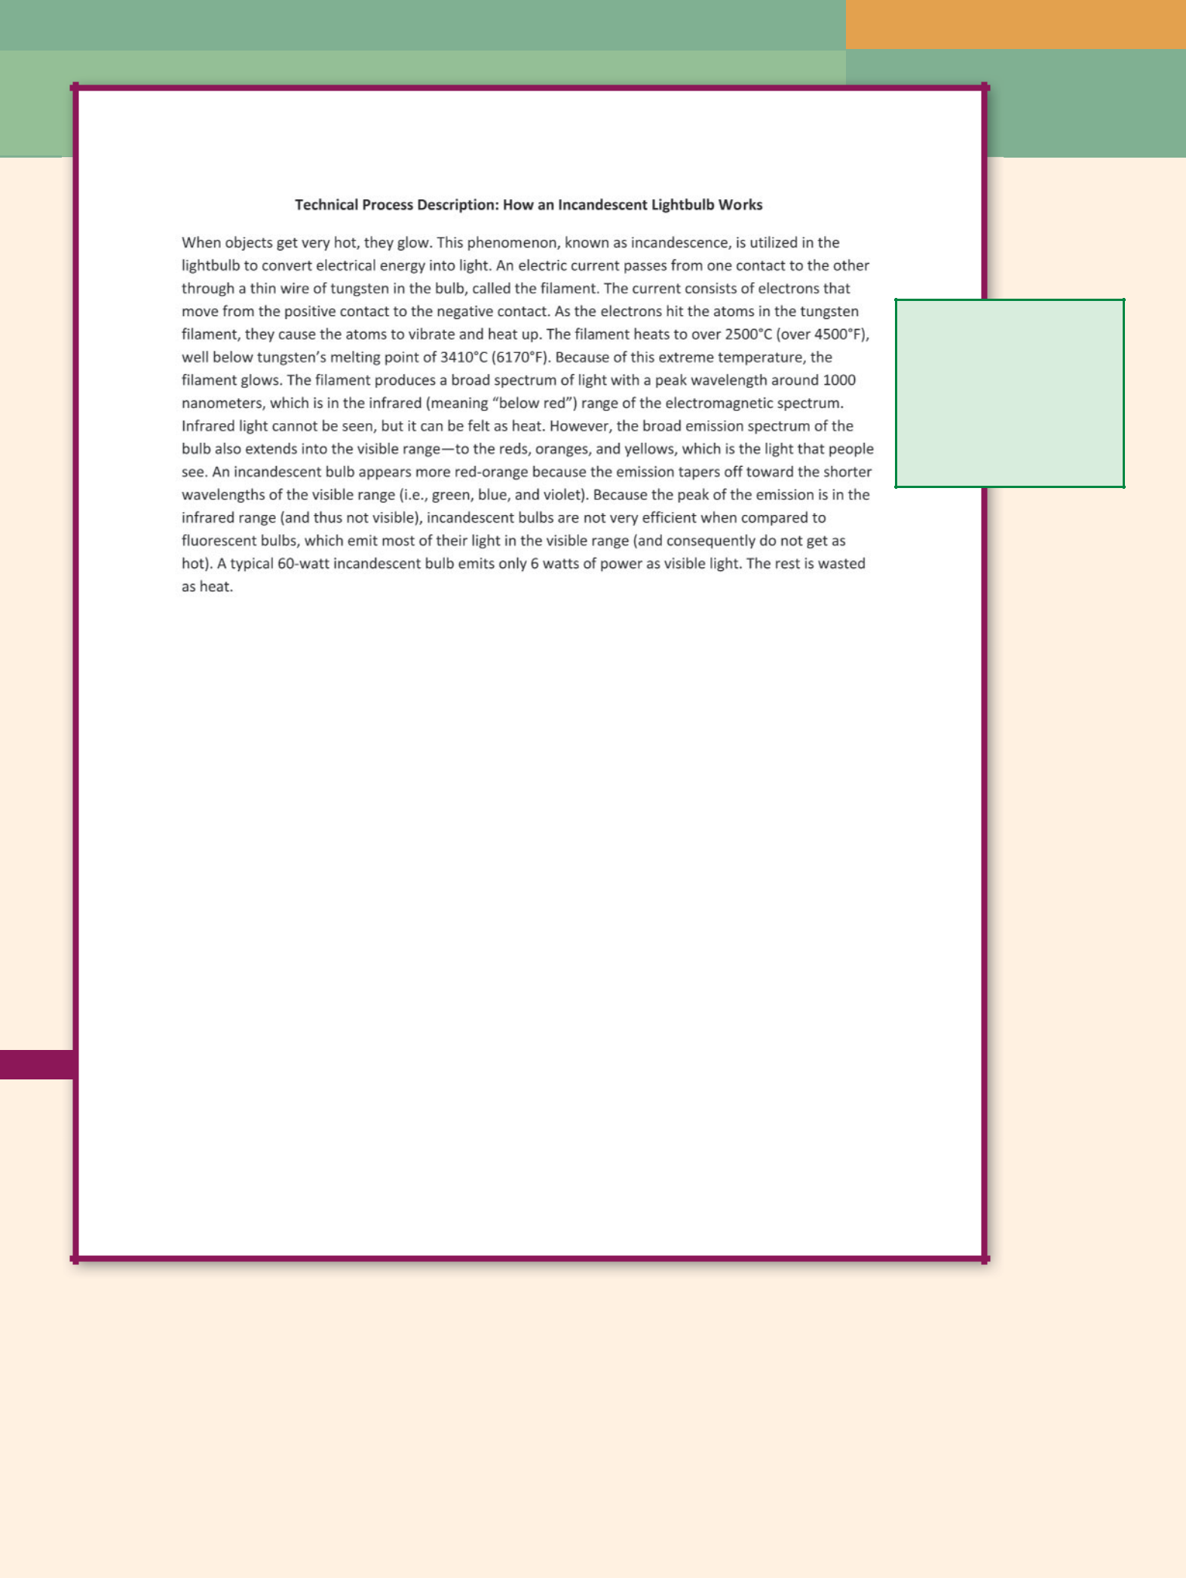

Follows a chronological

order; tells how the bulb

works, not how to oper-

ate the bulb; uses specific

measurements and technical

vocabulary to explain the

process accurately and

precisely

**Sample Technical Process Description: How an Incandescent Lightbulb Works**

*Source:* Frank B. Meyers, University of California, Berkley

Informative Reports **| 187**

****Writing@Work

|  |
| --- |
| Courtesy of Paige Heller |

Paige Heller is a physical therapist at an outpatient orthopedic clinic in Sedona, Arizona. She treats patients daily and provides written

documentation for each visit, including daily evaluation notes, periodic progress reports, and discharge summaries.

Paige’s writing must be clear and concise, yet thorough and rich in detail. “A good physical therapy document needs to be readable by a varied audience that includes the patient, other physicians, and employers. These reports may also be used for legal purposes, so they must include large amounts of information in a small amount of writing.”

To write a report that is brief and that contains all necessary information, Paige follows the “SOAP” formula for writing bulleted clinical notes. Each letter stands for its own bulleted item in the note:

1. *S* stands for *subjective*—the first bullet states what the patient reports.
2. *O* stands for *objective*—the second bullet states what the therapist observesand tests.
3. *A* stands for *assessment*—the third bullet is an analysis of the *S* and *O* points.
4. *P* stands for *plan*—the last bullet is a future/intended course of treatment.

Just as Paige writes her reports so they are useful for other practicing therapists and physicians, she must read others’ reports in order to provide the most advanced and tested treatment possible. “Physical therapy is an evidence-based practice, which means we dictate our treatments according to the results of research and studies in the field. I frequently access online medical journals to review such reports. I also read physician reports of surgeries or diagnostics

to better understand a patient’s condition or injury.” In other words, Paige’s technical writing proficiency depends in part on her technical reading skills. In turn, other physical therapy professionals rely on Paige’s technical writing ability, which is why accurate documentation is so important.

**188 |** Chapter 8

**GETTING STARTED ON INFORMATIVE REPORTS**

Professionals in business and industry use specialized reports to convey information about their work. This chapter presents the most frequently used informative reports: summaries and abstracts, mechanism descriptions, progress and periodic reports, and news releases. These specialized reports use standard forms. Once you learn how to use them, you can develop reports using information from jobs or personal experience.



**SUMMARY AND ABSTRACT** **Warm Up**



A **summary** is a condensed version of a document. When writing an essay, you generate details to develop or support a thesis and topic sentences. Summaries require writers to do the opposite: keep only general information and the most important details.



**Abstracts** are more condensed than summaries, often reducing documents toa thesis. The length depends on the audience’s needs and expectations.

Some summaries and abstracts stand alone; others begin a longer technical document. By condensing the report’s highlights before the audience reads the details, summaries save coworkers time. People at upper levels of an organization may choose to read only the summary sections of longer reports. They do so because their interest is in the big picture or health of the organization rather than the details or technical aspects of day-to-day operations.

Some employees use summaries to stay on top of the latest research and developments in their fields. These employees summarize publications in the career field as they emerge and file them for future reference.

Figure 8.1 on the next page is an article that an employee reads so that the employee can summarize it for his or her supervisor and files and for future reference. Figure 8.2 on page 191 contains two summaries and an abstract of the article in Figure 8.1.

Recall the last movie or play you watched. How would you respond if a friend asked, “What was the show about?” Using what you remember about the show, write the answer you would give to your friend.



To write a summary or an abstract:

1. When an oral presentation is given, take notes during the presentation or soon afterward. Thus, you are less likely to forget what the speaker said.
2. With a written document, read the document twice—or as many times as necessary to fully understand the content. As you read the second time, highlight the main ideas or cross out everything (all details) except the main ideas. Paraphrase main ideas. For longer summaries, choose a few important details to include. For abstracts, condense the paraphrased material.
3. In the summary’s first sentence, include the thesis or main point of the document using your own words and sentence structure.

Informative Reports **| 189**

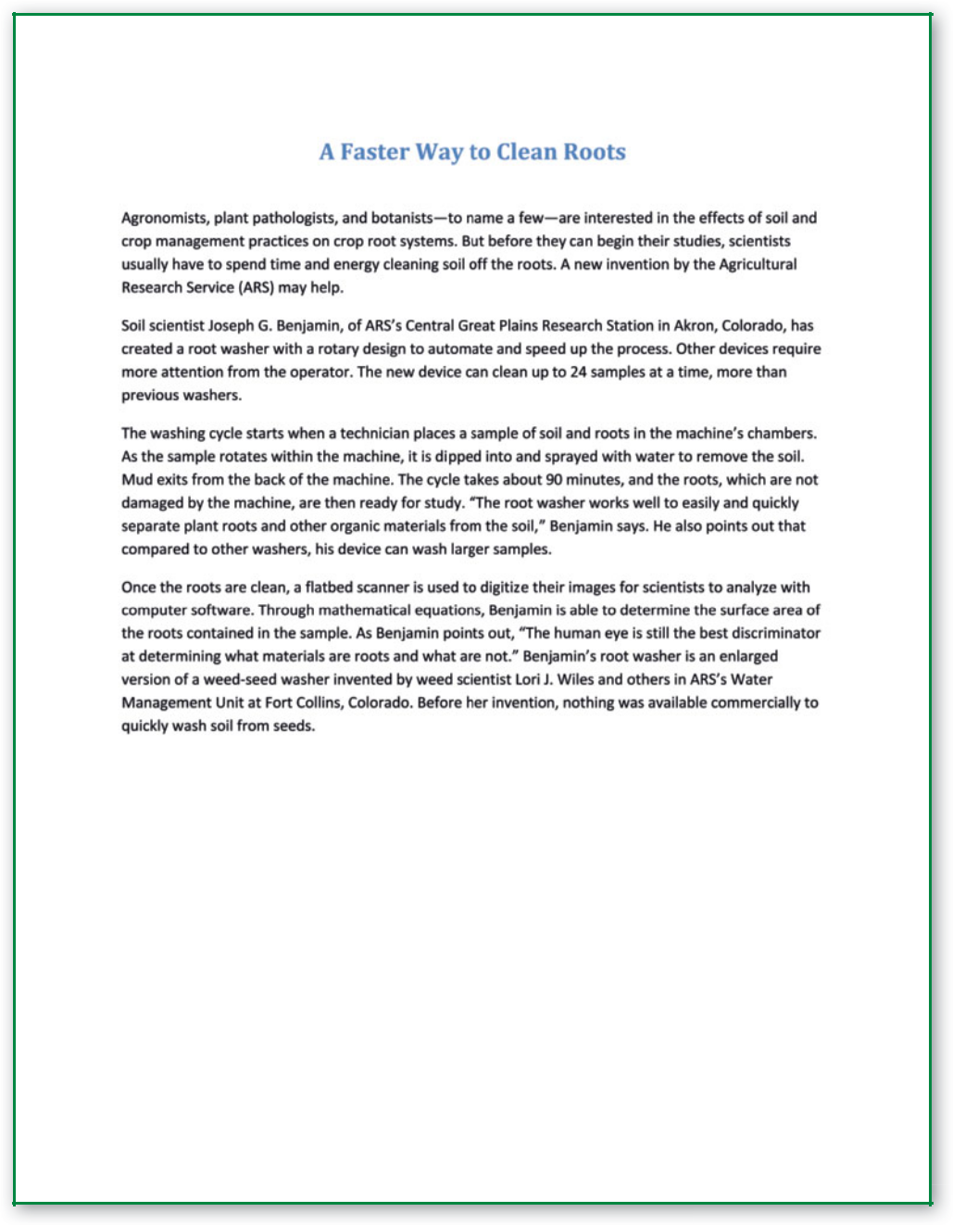

**Figure 8.1** Article to Be Summarized

*Source:* Elstein, David. United States. Dept. of Agriculture. “A Faster Way to Clean Roots.”

*Agricultural Research:* 2004 (52.1). Web. 10 Dec. 2009.

**190 |** Chapter 8



**LONG SUMMARY OF “A FASTER WAY TO CLEAN ROOTS”**

In “A Faster Way to Clean Roots,” David Elstein announces a technological breakthrough for people who study plants and crop management. While scientists normally use con-siderable time cleaning dirt from plant roots by hand before the plants can be studied, a machine created by soil scientist Joseph G. Benjamin offers help.

Benjamin developed a device to rotate and clean 24 plants at once, decreasing the need for scientists to handle the plants and speeding the process. During washing, the machine dunks and shoots water at the roots but does not harm or change the root system. The water takes the mud with it when it drains from the machine.

When the clean roots are removed from the new machine, Benjamin’s device uses a

flatbed scanner, computer software, and mathematical equations to calculate the surface area of the roots. However, the inventor notes that the machine is not as effective as the human eye at distinguishing roots from other materials.

Benjamin based the design of his invention on a weed-seed washer invented by scientist Lori J. Wiles and colleagues at the ARS Water Management Research Unit in Fort Collins, Colorado.



**SHORT SUMMARY OF “A FASTER WAY TO CLEAN ROOTS”**

In “A Faster Way to Clean Roots,” David Elstein announces a technological breakthrough for people who study plants and crop management. Before soil scientist Joseph G. Benjamin’s creation of a machine to clean soil and organic matter from plant roots, scientists had to painstakingly remove the dirt from the root system of plants they wanted to study. Benjamin’s invention does not damage the roots, and it mechanizes and speeds the preparation. Compared to other machines, Benjamin’s rotary-design wash cycle prepares 24 samples for study faster and with less handling. When the plants are clean, Benjamin’s device uses a flatbed scanner, computer software, and mathematical equations to calculate the roots’ surface area.



**ABSTRACT OF “A FASTER WAY TO CLEAN ROOTS”**

In “A Faster Way to Clean Roots,” David Elstein announces a technological breakthrough for people who study plants and crop management: soil scientist Joseph G. Benjamin’s creation of a machine to clean soil and organic matter from plant roots without damag-ing the roots.

**Figure 8.2** Examples of Summaries and Abstract

Informative Reports **| 191**

 Warm Up



Examine the pen or pencil you are using to take notes. Briefl y describe its parts and their functions.

**192 |** Chapter 8

1. Make clear what you are summarizing. With an article, introduce the source in the first sentence by including the title and author’s name. For a speech or meeting, credit the speaker in the opening sentence.
2. Decide whether your audience needs a few details or only main ideas. For long summaries, include only details that are especially important. For short summaries, leave out details. For abstracts, include only the most important general ideas. Be concise. Reduce the original document to the main idea in a few sentences.
3. Keep your summary information proportional to the original. If the author spent four paragraphs on one topic and two paragraphs on another, your summary should give proportional time and emphasis. For example, in your summary or abstract, do not include more information from the two-paragraph topic than from the four-paragraph topic.
4. Write in present tense.
5. Paraphrase; do not copy word for word.
6. Quote sparingly, if at all, and use quotation marks correctly.
7. Provide transitions to keep the summary from sounding choppy.

Do *not* give your opinion. A summary or an abstract should be objective.

 **STOP AND THINK**

If a summary includes three of an article’s five main points, is it effective? Why or why not?



**MECHANISM DESCRIPTION**



A **mechanism description** describes the main parts of a device or machine. It explains what the purpose of the mechanism and overall design is, what the parts are, what they look like, and what their function is.

Mechanism descriptions are used in catalogs, instruction manuals, and employee training. Examples of mechanisms in the workplace include car parts, furniture, kitchen tools, doorstops, pencil sharpeners, and more sophisticated machines such as an engine and a DVD player. Mechanism descriptions are often included with instructions in product packaging.

Consumers can find a mechanism description in a manual that comes with new equipment, such as a computer or can opener. This description tells what the parts are, how they fit together, and what their functions are. Technicians and operators use the description to become familiar with the characteristics of the machine and to troubleshoot problems. New employees use a mechanism description to learn job responsibilities and safety procedures. Decision makers use mechanism descriptions to reach informed decisions, perhaps comparing current equipment with equipment proposed for purchase.

Figure 8.3 on the following page is a mechanism description that a community college electronics student produced to demonstrate his understanding of an everyday object that people use. The audience for the report was the instructor, other electronics students, and anyone curious about how things work.

To write a mechanism description,

1. Take notes, describing every part in detail. Assume that you are on the telephone. You must describe a mechanism that the listener has not seen.
2. Use **spatial order.** That is, explain the parts from left to right, right to left, top to bottom, bottom to top, or whatever pattern is logical.
3. Open with an overall physical description of the mechanism, a statement that identifies its general purpose (what it is designed to do), and a preview of its parts.



**TYPICAL READER**



Either a technician or a professional needing technical specifi cations for a mechanism; any person who needs to understand how a mechanism works.

**WRITER’S FOCUS**

Writing thorough and clear descriptions and explanations in a readable format with accu-rate, precise details, including measurements, materials, and appropriate graphics.

1. Divide the mechanism into its parts and discuss each part under a separate heading. Use proper names of the parts. Place headings in the same order you used in the preview list.
2. Provide a precise physical description of the parts. Include size, color, location, and material (what the mechanism is made of).
3. Include the purpose or function of each part.
4. Provide a graphic of the mechanism. Include exploded (enlarged) views of parts that are too small to be easily seen. Add callouts to label each part.
5. Use active voice whenever possible.

Do *not* explain how to operate the mechanism. Instead, describe what it does, what it looks like, what its parts are, and what they look like and do.



|  |
| --- |
| Blend Images/JupiterImages |

Informative Reports **| 193**

Introduction: a general over-

view of the bulb, its purpose,

the diagram, and the parts,

which become headings for

the remainder of the report

Basic parts identified in

callouts in the diagram

Parts described in detail

using precise measurements

and numerical specifications

|  |  |
| --- | --- |
| Filament | Glass bulb |
|  |
| Inert gas |  |

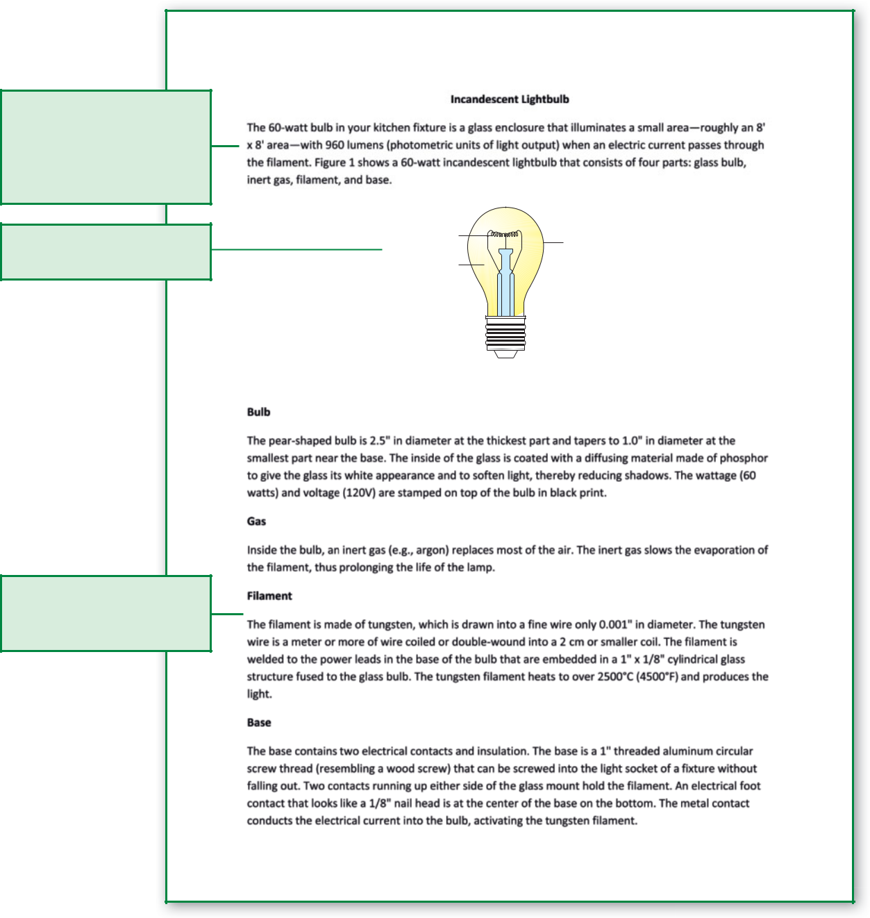

**Figure 1.** 60-watt incandescent lightbulb

**Figure 8.3** Example of a Mechanism Description

 **STOP AND THINK**

In a mechanism description, should a writer describe a metal disk as (a) about the size of a penny or (b) 1/2" in diameter? What organizational pattern is used in mechanism descriptions?



**194 |** Chapter 8

**PERIODIC REPORTS** **Warm Up**



**Periodic reports** explain accomplishments for all projects of a work groupor of an entire organization over a specified time period. For instance, when you listened to your governor make a State of the State address or the President make a State of the Union address, you heard a periodic report. These speeches explore the many ongoing projects of the state or nation for the year. Periodic reports may cover different periods: a week (weekly), a month (monthly), three months (quarterly), or six months (semiannually).

Businesses and nonprofit organizations use periodic reports to inform shareholders, clients, vendors, donors, and employees of the organization’s accomplishments and challenges. Figure 8.4 on the following two pages is an example of a periodic report prepared by a student intern.

To write periodic reports,

Consider the organizations you belong to, participate in, or are concerned about. How do you learn about the status, or “health,” of the organization?

1. Consider all activities and accomplishments of the organization for the specified time period. Begin by noting the time period. Are you sharing information about the last two weeks, the past month, or the fiscal year? (A **fiscal year** is the operating year, such as the academic year, which often runs from July 1 through June 30.)

1. Meet your audience’s needs. What are the audience’s concerns, history with the writer and the project or organization, and roles?
2. Organize tasks so you can report them logically. Once lists are complete, categories of tasks become subheadings under a major heading. Organize so the reader can find important information easily.
3. Format for the audience. Many longer periodic reports are manuscript-formatted, appearing like an essay or a book with a title. These reports offer formality and distance appropriate for a diverse audience. When written for an internal reader, a short periodic report may be formatted as a memo. For an external reader, the report may be formatted as a letter.
4. For the introduction, develop an overview that briefly presents the highlights of the report. Mention each idea included in a major heading. Also state the reporting period, the time for which the document describes activities or progress.



1. For the body, compose a section for each activity category or type of work undertaken during the reporting period, with section headings and sometimes subheadings organized from most important to least important. For instance, the monthly activity report of a U.S. Navy recruiter might include the following work areas (and headings):

Job Fairs, School-Based Meetings, Office Conferences, and Public Speaking Events. Under each heading, the recruiter describes, from most to least important, accomplishments during the reporting period. In the rest of the report, the recruiter may note problems encountered.

1. In the conclusion, highlight any key ideas and refer to the next report.

**TYPICAL READER**



Any person involved with or interested in the organization, such as employees or shareholders, who would like to know about the activities and accomplishments of the organization.

**WRITER’S FOCUS**

Presenting a logically organized, detailed description of what an organization has done during the reporting period.

Informative Reports **| 195**

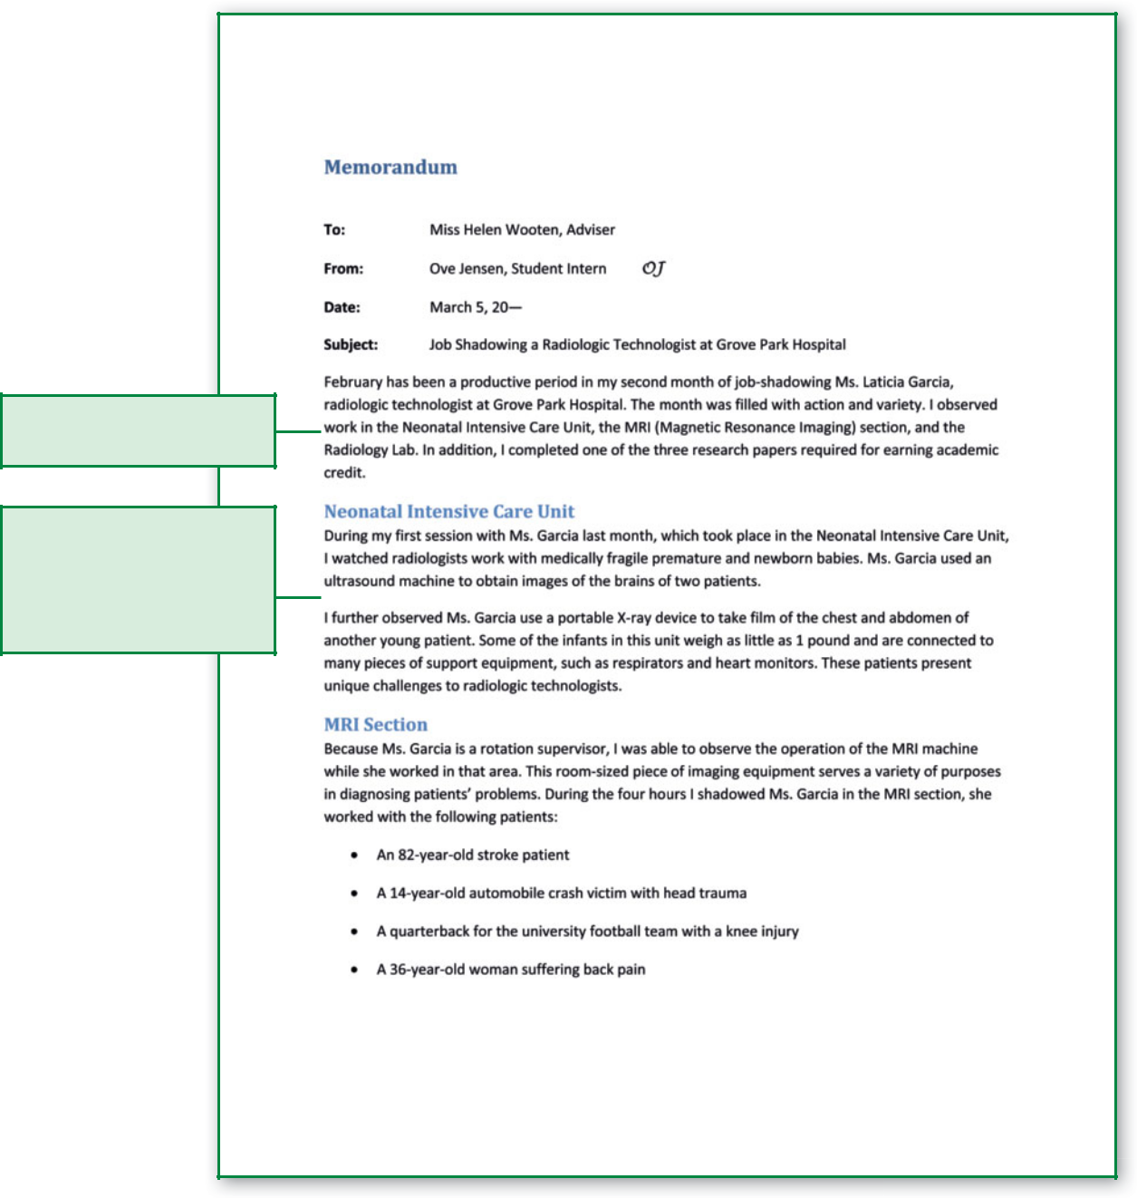

Gives highlights of entire

report

Provides as many specifics

as possible; is organized

from most important

information to least

important information

**Figure 8.4** Periodic Report

1. Check for accuracy, particularly in statistics and names.
2. Use lists, numbered or set in columns, whenever possible to ensure easier reading.
3. Divide long discussions into paragraphs to reflect groups of ideas.

Periodic report writers should *not* include their opinions, instead providing facts and allowing readers to draw their own conclusions.

**196 |** Chapter 8

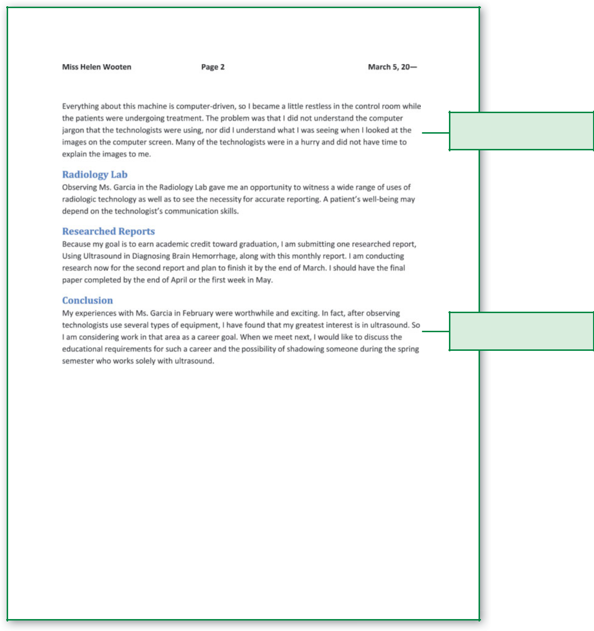

Notes and explains problem area

Looks forward to the next

report and meeting

**Figure 8.4** Periodic Report,*cont*.

 **STOP AND THINK**

What three types of information are usually included in the introduction of a periodic report?



Informative Reports **| 197**



 Warm Up

Think about the grade reports you receive from school. What is the writer’s purpose in presenting this report? Determine the relationship between the writer and the audience. Now think about how grade reports changed as you progressed through your academic career from elementary to middle school to your current level of schooling.

**PROGRESS REPORTS**



Like periodic reports, **progress reports** are documents that report progress for a period of time. Unlike periodic reports, which cover all of an organization’s work, a progress report describes what has been done during a specified time on only one project, such as work on the construction of a building. A progress report covers in detail all achievements as well as plans for the upcoming reporting period toward completing one project.

Anyone in an organization may need to report progress made on a project. Readers may use information in a progress report to make decisions, to take actions, or to file for future reference. Figure 8.5 shows a progress report.

To write a progress report:

1. Organize a progress report to answer the readers’ most important questions first. Use the following outline to plan for progress reports. Under each heading, the writer may add subheadings if several ideas will be covered in that section.



|  |  |
| --- | --- |
| **HEADING IN REPORT** | **WHAT THAT SECTION COVERS** |
|  |  |
| *Introduction* | Report topic, purpose, and reporting period |
|  |  |
| *Work Completed* | What has been done |
|  |  |
| *Work Scheduled* | What needs to be done |
|  |  |
| *Problems/Projections* | What has gone wrong and when the work will be |
|  | finished |
|  |  |

1. In the opening or introductory section of the progress report, Name the project.

Indicate the **reporting period,** which is the time the report covers.

State the purpose of the report (to tell readers the status of the project).

1. Use *I* or *we—*first person—where appropriate. You take responsibility for your actions and opinions by using *I.* Using *I or* we is not only acceptable, but also encouraged.



**TYPICAL READER**

Anyone inside or outside the writer’s orga-nization needing information on progress toward completion of a task.

**WRITER’S FOCUS**

Clearly describing achievements and plans toward completing a task in a standard organizational plan.

1. In the Work Completed section,

Note again the time period you cover. (This is optional; if it is included, it usually appears beside the heading or in the opening sentence of the section.)

Use past tense verbs.

Use subheadings (to separate tasks) or bulleted lists. When three or more tasks or topics are included in this section, subheadings are necessary. When only one or two tasks are included, subheadings are optional.

**198 |** Chapter 8

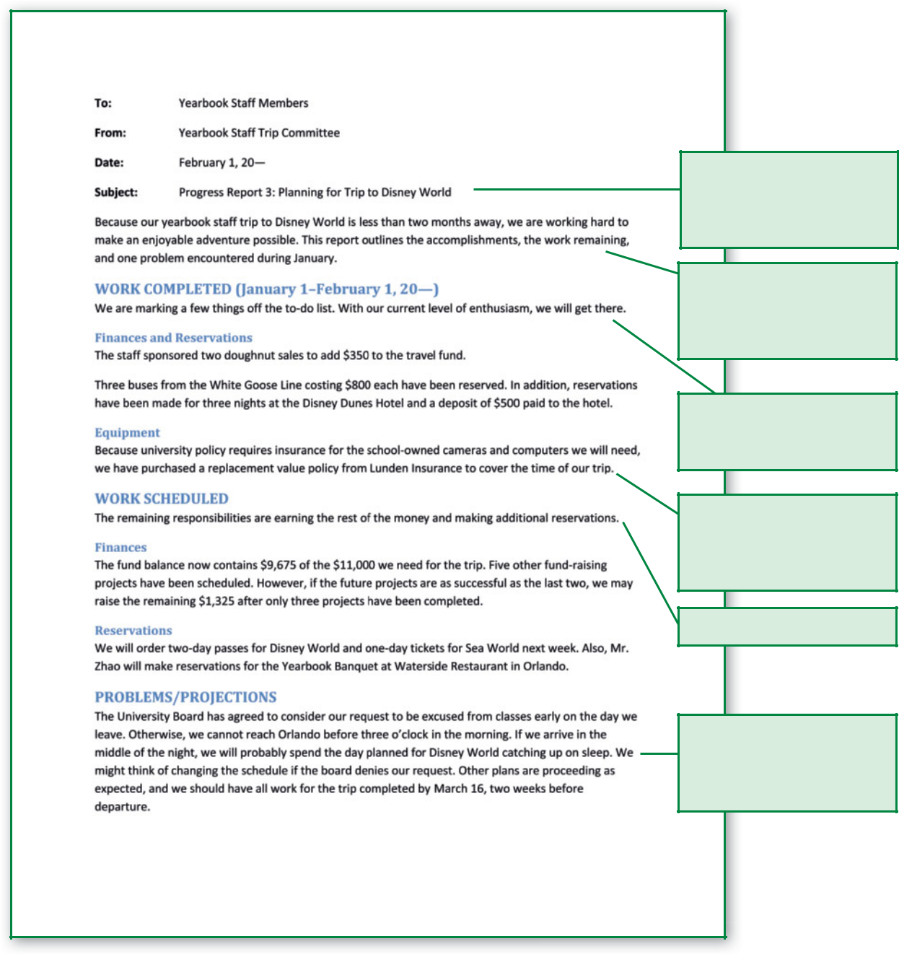

Indicates that this is the

third progress report on this

project; notes the report

topic

Describes the project being

reported on, gives the

reporting period, and states

the purpose of the report

Covers what has been done

on the project; includes the

reporting period

Includes subheadings if

the work accomplished

falls under two or more

categories

Covers work yet to be done

Explains any difficulties that

may affect the project; gives

a revised completion date if

problems have caused delay

**Figure 8.5** Internal Progress Report

Informative Reports **| 199**

**Communication**

**Dilemma**

James Berry, a pediatric occupational therapist, is tempted to give a parent a glowing report even though the 3-year-old patient is not making significant improvement in therapy sessions. Mr. Berry likes the parent and does not want to add to the parent’s stress.

**Think Critically**

What are possible effects of misinformation in Mr. Berry’s reports?

The U.S. Food and Drug Administration (FDA) publishes a website that contains links to press releases of the past decade. You will fi nd everything from food and drug research to biologics and radiation protection.



Go to the NET Bookmark for Chapter 8. Find a news release that interests you and print it. Write several paragraphs to explain if and how it uses the guidelines for eﬀ ective news releases.

*www.cengage.com/school/bcomm/techwtg*

Provide sufficient details and explanations about each job completed. Because your reader is probably most concerned about what you have done on the project, ensure that this section is clear and accurate. Place your most important ideas first. After all, this is your opportunity to tell what you have achieved.

1. In the Work Scheduled section,

Tell your audience what work needs to be done in the next reporting period.

Use future tense verbs.

Separate and emphasize each major task or job with subheadings, as you did in the Work Completed section. Remember to use subheadings when you have three or more tasks. Otherwise, subheadings are optional.

* 1. In the Problems section,

Describe any obstacles to completing the job. Inform the reader of anything that has affected the quality or quantity of work.

Either list and number or describe these problems in paragraphs.

Be honest and direct.

Report just the facts unless you need to assign responsibility for problems. Remember that finger-pointing can be counterproductive.

1. In the Projections section, give readers a new completion date if problems have stalled the project so that the original date cannot be met.

 **STOP AND THINK**

While both periodic and progress reports are issued periodically or in set increments of time, what is the difference between the two reports?



**200 |** Chapter 8

Any person who appreciates news.

**WRITER’S FOCUS**

**Planning and writing a news release that is eﬀective enough in content, style, organization, and format to win the news editor’s approval for publication and that is interesting enough to gain the attention of the ultimate audience; organizing so that essential information comes fi rst and is not lost if the editor must cut the story because of space or time constraints.**

**TYPICAL READER**

**NEWS RELEASES**

News releases, also called press releases, are reports of events or facts prepared for the **media,** which are systems or means of mass communication. The goal of the release is to inform the public of, for example, an employee promotion or a company expansion.



One type of press release is the public service announcement (PSA). **PSAs** differ from other news releases in that they present facts beneficial to the public. PSAs, for example, announce Red Cross blood drives, city council meetings, fund-raisers, and other public events. People and organizations send news releases to the media to share information with the public.



In many large organizations, **public relations,** the communication between a company and the outside world, is handled by departments that write news releases to help the company maintain a positive image. For instance, if a company executive is involved in a scandal, the public relations staff may prepare a news release to present the company’s view and restore public confidence.

In smaller organizations without public relations departments, any employee may write a news release. The maintenance director might write a release describing the company’s recycling efforts, a retail manager might cover the store’s planned expansion, and a volunteer group’s administrative assistant might outline the organization’s upcoming fund-raising project.

Because the writer sends the release to select news agencies, the first readers are editors and news directors. They decide whether the news release will run. If the information is newsworthy and the release is well written so that little editing is required, the chance that it will be published increases. Other influential factors include space and time constraints.

If the release is published, the second audience is the public. The public is anyone who reads a newspaper or magazine, watches television, uses the Internet, or listens to the radio. Specialized media agencies receive news releases targeting a particular audience, so the second audience might also be a select group.

For instance, you are probably familiar with television stations that target specific people: MTV targets music lovers; TNN attracts country music

fans; CNN focuses on people interested in world, economic, and political news; and the Disney Channel targets children. Audiences are looking for the same thing—timely and interesting information.

On the next page, Figure 8.6 shows a news release with a triangle indicating the part of the release an editor chose to publish. The last two paragraphs, which contained the least important information, were cut.

To write a news release,

1. Begin by analyzing the audience. Consider the editor or news director as well as the public.
2. Answer the classic Reporter’s Questions: Who? What? When? Where? Why? and How? With answers to those questions, you have the most important information to include in the news release.

Warm Up



Recall news relating to business or industry you have seen, heard, or read in the last week from television, radio, print, or online media. With that news in mind, answer the following questions: What parts of the story do you remember? What made the story memorable? What elements of the story do you think business or industry provided? What elements were probably the result of a reporter’s investigation?



Informative Reports **| 201**

Complete the *Reorganizing* *an Ineﬀective News Release* worksheet available at www. cengage.com/school/bcomm/ techwtg. Click the link

for Chapter 8; then click Data Files.

**Figure 8.6** Model News Release Cut by Editor

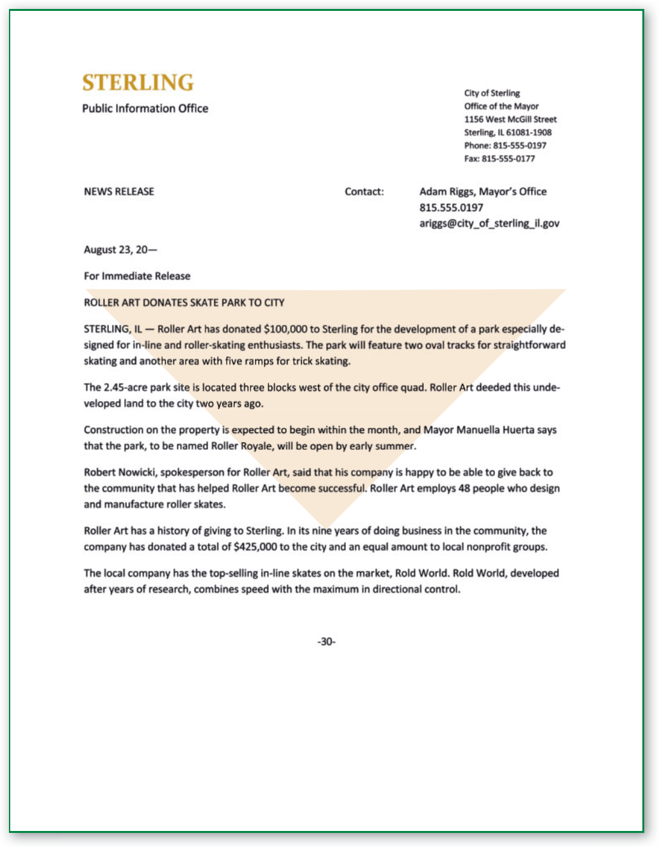

Figure 8.7 shows an illustration of this idea-packed opening for a news release. Notice where the Reporter’s Questions are addressed.

1. Beyond the Reporter’s Questions, ask yourself these questions: (a) What will interest my audience? (b) What will grab their attention? (c) What would they ask if they could?
2. Plan for accuracy. Check your prewriting notes for accuracy in the following:

Facts

Numbers and statistics

**202 |** Chapter 8



Lakeside High’s 6’7” senior Reggie Watson ended a year of suspense for

recruiters from a number of big-name schools Tuesday, March 15, 20—,

when he signed a letter of intent with his father’s alma mater, Notre Dame,

here in his family’s Watauga home.

Who?

When?

What? Why? How?

Where?

**Figure 8.7** Reporter’s Questions in News Release Opening

Names

Locations Quotations

Completeness (“the whole truth”)

With correct text, releases will have a greater chance of being published.

1. Plan for credibility. Exaggerations are overstatements or additions beyond the truth that can ruin a person’s credibility. Instead, use information that can be verified. Avoid superlatives such as *the best,* *the fastest,* and *the worst* unless you can document or prove thestatement. If your release opens with “R. J. Birch, the fastest 10K runner in the state,” make sure you have her race times or other proof of your statement.
2. Compose the headline carefully because it will be read first. Include an active verb. Use present tense for current events, past tense for events already concluded, and future tense for scheduled activities. For example, the headline HALIFAX ACADEMY TO HOST STAR TREK CONVENTION uses an active verb that indicates future time (*to host*) because the event has not yet occurred. Be aware that your news release will compete with others for space or airtime (time to deliver a news story). Thus, the headline is your chance to make a positive first impression on the reader.
3. Open the body of the release with a **hook**—catchy wording or an idea that attracts attention. Dynamic wording or an intriguing idea seizes the audience’s attention. Below are hooks used to open news releases.

The nets are still hanging in Memorial Coliseum after last night’s City League upset, but only because the Knights expect to return for them during the playoffs.

When 600 first-year students show up for orientation at Schantz College on Saturday, they will receive something besides their dorm assignments.

The Easter Bunny Brought What?



Those opening sentences attract attention so readers or listeners will want to know more.

Informative Reports **| 203**

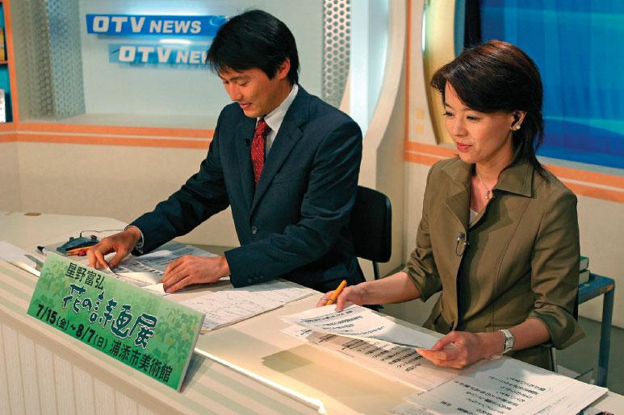

|  |
| --- |
| ©Zoriah/The Image Works |

1. Order ideas from most important to least important and begin with the important answers to the Reporter’s Questions. Organizing from most to least important achieves several purposes:

You make editors’ work easier and the story’s publication more likely.

You help readers find the most important information quickly and easily—even if they do not read the entire article.

Making cuts is easier, and you have more control of how they are made.

If a news director has 20 seconds of airtime and your news release is

30 seconds, the news director must cut 10 seconds or choose not to use it. Likewise, print editors sometimes must cut inches to fit releases into the space available.

1. Format news releases so information the reader needs stands out, editors can make changes easily, and news anchors (who might read the text on the air) can easily follow the document. For illustrative purposes, the release is divided into three units: the top of the page or introductory information, the body or story, and pagination cues. Refer to Figure 8.8.
2. Properly format introductory information. Many large companies

create letterhead for news releases. It is printed with the company name, postal and web addresses, telephone number, logo, and the words *NEWS* *RELEASE.* If your organization does not have special letterhead, useplain 8 1⁄2" 3 11" paper. Use the following guidelines for introductory format:

Begin with the words *NEWS RELEASE* in all capital letters. Key the source of the document in initial caps if letterhead is not used.

**204 |** Chapter 8

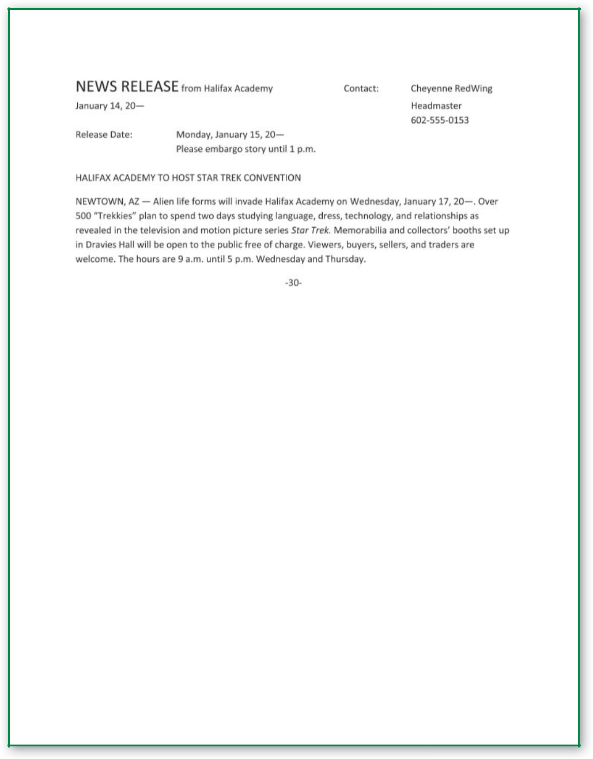

**Figure 8.8** News Release Format

Key *Contact* and a colon flush right across from *NEWS RELEASE.* After the colon, enter the name of the person responsible for the release as well as the person’s job title and phone number.

Record the date the document was written beneath *NEWS RELEASE.*

Use *For Immediate Release* or place *Release Date* and a colon at the left margin under the date. After the colon, key the date and the specific time the information should be made public.

Writers occasionally request a release to be held for a period of time before publication. If you want a story to be held, beneath or

Informative Reports **| 205**

**Focus on**

**Ethics**

Isaac Nonn is a campaign worker for a candidate running for the state legislature. Isaac’s candidate is slipping in the polls, and the opposition is gaining in popularity. Isaac recently received a packet in the mail from an anonymous sender, indicating that the opposition candidate was expelled from college for cheating before she transferred to the university from which she ultimately graduated. Isaac is thinking about forwarding the materials to local media outlets—perhaps anonymously.

**Think Critically**

How should Isaac handle the situation?

beside the release date, key *Please hold until [desired release time]* or *Please embargo story until [desired release time].* **Embargo**means “towithhold or delay publication.”



Give the news agency a suggested headline in all capital letters.

1. To format the body of a release, preface it with a **dateline,** which identifies the location of the story. Key the dateline in all capital letters. In Figure 8.8, NEWTOWN, AZ is where the story takes place. After the location, (a) leave a space, (b) key a dash, and (c) leave another space.
2. Use pagination cues, a special code to help readers follow the text and read from one page to another. To use these cues,

Key the word *-more-* centered at the bottom of the page when the release will be continued on the next page.

End news releases with *-30*- or *###* centered after the last line.



*Do not* promote a product or a service in your release. If you are temptedto do so, remind yourself that news is who did what, where, when, why, and how, while advertisements are how new, improved, or cost-effective something might be. Editors rarely publish releases that read like sales literature.

 **STOP AND THINK**

Before a news release is published, what reader or readers must approve it?

